[Organisation] · PHASE B · TEMPLATE T-04
Architecture Definition Document
Business Architecture
Baseline, target and gap for the [Organisation] 2030 Wave 1 cycle
Field | Detail
Version | 0.1 — Draft
Date | May 2027
Cycle | First ADM cycle, Phase B
Owner | Business Domain Architect
Approver | Architecture Board
Template | T-04 Business Architecture Definition
Classification | Internal

Contents
1. Scope and viewpoints
2. Baseline business architecture
3. Target business architecture
4. Capability assessment
5. Value streams and enabling capabilities
6. Products, channels and the control cycle
7. Gap analysis
8. Candidate roadmap components
9. Stakeholder review record
10. Open items
11. Findings
12. Approval

This document does not restate the artifacts beneath it
Eight Phase B artifacts carry the detail. This document references them and holds only what none of them holds: the gap between baseline and target, and the work packages that close it. Where a figure here differs from the artifact it came from, the artifact is right and this is stale.

1. Scope and viewpoints
 | Detail
In scope | [Organisation] Life, [Organisation] Short-Term, [Organisation] Funeral, Group Operations, Group Technology, Group Data and Group Finance, per SAW-2027-01.
Out of scope | [Organisation] Namibia and [Organisation] Botswana, which are federated. Investments and Marketing & Brand, which have no architecture engagement.
Level of detail | Capabilities to level 3, value streams to stage, services to service level. Process detail belongs to the operating units and is not held here.
Time horizon | Baseline as at April 2027. Target as at December 2030, with the Wave 1 position at December 2028 called out separately.

1.1 Viewpoints used, and who they were built for
Viewpoint | Artifact | Content | Principal stakeholder
Capability | Business Capability Map | 556 capabilities, 134 assessed at level 3 | Chief Executive, line of business Managing Directors
Value stream | Value Stream Definition | 7 streams, 38 stages | Chief Operating Officer, Claims and Distribution executives
Organisation | Organisation Map and Chart | 23 map nodes, 102 positions | Group HR Director, Chief Information Officer
Service and function | Business Service and Function Catalog | 20 services, 12 functions | Line of business Managing Directors
Actor and role | Actor and Role Catalogue | 18 actors, 18 roles | Group HR Director
Information | Information Map | 24 concepts, 11 subject areas | Chief Data Officer
Customer experience | Customer Journey Map | 7 phases, 5 moments of truth | Chief Operating Officer, Chief Distribution Officer
Process | Process Modelling Convention | 3 worked BPMN examples | Operating unit heads

2. Baseline business architecture
What is true as at April 2027, including what works. Each row references the artifact that holds the detail.

Domain | Position | What it means
Capabilities | 556 capabilities, 134 assessed at level 3. Weighted mean maturity 2.51 against a target of 3.90. | 76 of 134 are Critical and 47 High. Six Critical capabilities sit at maturity 1.
Value streams | Seven streams, 38 stages. Thirteen stages carry no measure at all. | The two streams measured at every stage, Acquire Cover and Settle a Claim, are the two that have been automated. The other five are unmeasured because nothing records them.
Organisation | 23 nodes: 4 lines of business, 7 functions, 3 collaborative teams, 8 partners. 102 positions. | Five nodes appear in no recorded interaction, including a whole line of business and all three collaborative teams.
Services and functions | 20 business services and 12 business functions. | Seven services are not channel agnostic, and all seven are customer-facing. Only two services currently meet their service level.
Actors and roles | 18 actors and 18 roles. | Eight roles have no actor recorded as performing them, including Data Owner. Ten actors hold no role, correctly, and all ten are external.
Information | 24 information concepts across 11 subject areas. | 23 concepts are owned by a role no actor performs. Three have a contested authoritative source; one has none at all.
Products | 18 products, 2.55 million policies in force, R37.8bn of product gross written premium. | Nine of 18 are coded rather than configured, which is why product configuration takes 120 days.
Customer experience | One mapped journey, seven phases, five moments of truth. | Two phases sit outside every value stream. The emotional low point is the 48-hour claim promise, delivered at an eleven-day median.

3. Target business architecture
The same structure, with differences highlighted rather than described afresh.

Domain | Target | How it differs
Capabilities | Weighted mean maturity 3.0 by December 2028 and 3.9 by 2030. | 43 capabilities marked Invest and 26 marked Build. Sustain and Optimise account for the remaining 64 and receive no funded change.
Value streams | Every stage measured, and the two stages that exist only because of the systems beneath them removed. | Settlement no longer waits for an overnight batch; product configuration is no longer a software release.
Organisation | Collaborative teams carry recorded flows, and every role has an actor. | Nine operational roles added to the catalogue under change request; the Data Owner role filled before identity work proceeds past G2.
Services and functions | Every customer-facing service channel agnostic. | The seven that are not become one service each, rather than one implementation per channel.
Information | Every concept owned by a role somebody performs, and every authoritative source designated. | The Data Governance Council designates sources before the identity hub is built on them.
Products | Rating and product configuration held outside the policy administration platform. | Configuration falls from 120 days to 30. The coded nine migrate to configuration as their platforms allow.
Customer experience | The claim promise is met, and the journey does not end in silence. | Funeral settlement at two days. A closing contact after every claim, owned by a named role.

4. Capability assessment
134 capabilities assessed at level 3 for criticality, current and target maturity, disposition and differentiation. The full assessment is in the Business Capability Map.

Measure | Position
Capabilities assessed | 134 of 556, at level 3
Weighted mean maturity | 2.51 current against 3.90 target
Criticality | 76 Critical, 47 High, 11 Medium
Disposition | 60 Sustain, 43 Invest, 26 Build, 4 Optimise, 1 Outsource
Differentiation | 24 Differentiating, 25 Advantage, 49 Parity, 36 Commodity
Critical capabilities at maturity 1 | 6
Capabilities with no maturity gap | 26

Sixty-four capabilities receive no funded change
Sixty are marked Sustain and four Optimise. Stating what will not be invested in is as much a part of the target as stating what will, and it is the part most likely to be quietly reversed when the roadmap meets the budget.

5. Value streams and enabling capabilities
Seven streams, 38 stages, each stage enabled by named level-2 capabilities. The Value Stream Definition holds the detail; the map below is the summary.
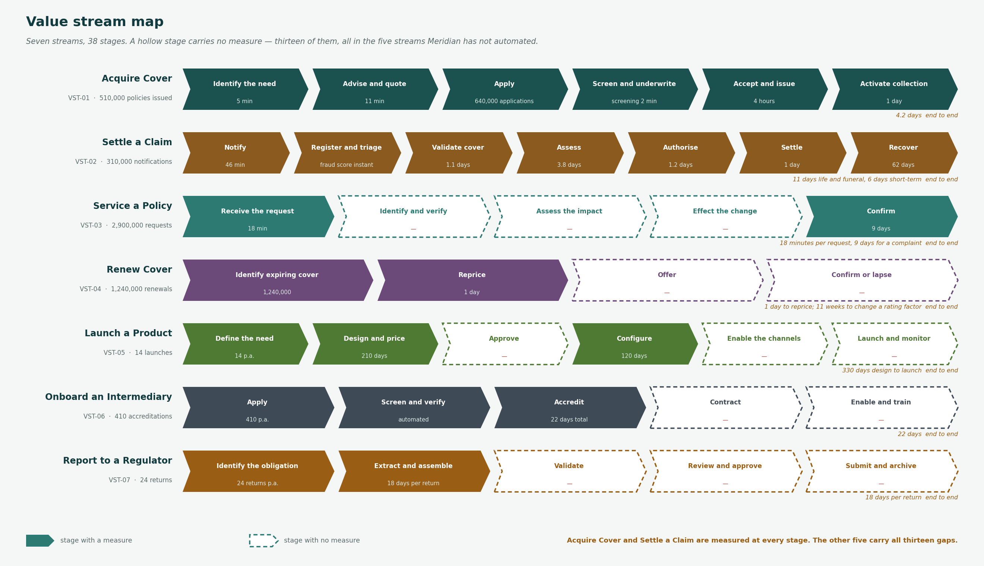
Figure 1 — The seven value streams. A hollow stage carries no measure.

6. Products, channels and the control cycle

6.1 Product architecture
Measure | Position
Products in force | 18, of which 17 in market and 1 in pilot
Policies in force | 2,545,910
Product gross written premium | R37.8bn
Configuration model | 9 configured, 9 coded
Consequence | Product configuration takes 120 days because a coded product change is a platform release

6.2 Channel and intermediary model
The metamodel holds no channel object. Channel economics, volume and persistency are therefore not available at the level template T-04 asks for, and this section is incomplete.
What is known: distribution runs through tied agency, independent brokers, bancassurance, direct and embedded partners. Broker-placed business is the largest channel by premium. Quote-to-issue is 31% digital across all channels and materially lower for commercial. The Channel and Intermediary Matrix is a Phase B artifact that has not been built.

6.3 Actuarial control cycle
Also incomplete for the same reason. The Actuarial Control Cycle diagram is a Phase B artifact that has not been built.
What is known: pricing basis, experience analysis, assumption setting and reserving sit with Group Finance and Actuarial, 64 actuaries. Experience monitoring is quarterly and manual, and product design takes 210 days against a pricing cycle that should inform it.

Two sections of this document are incomplete, and are marked as such
Template T-04 requires a channel and intermediary model and an actuarial control cycle. Both depend on Phase B artifacts that have not been built. They are recorded as incomplete rather than filled with material that would read as architecture and is not.

7. Gap analysis
Fourteen gaps between the baseline and the target, each with the work package that closes it. One has no work package, and that is stated rather than corrected.

Area | Baseline | Target | Type | Work package
Customer identity | Four masters, no shared identifier, 640,000 unmatched records | One resolved identity across all four | Build | WP-03 Customer identity hub
Claims assessment | 3.8 days, manual, no prior claims history | 2 days, with history in view at assessment | Enhance | WP-07 Claims workflow
Claims settlement | Payment held for the overnight batch | Instruction issued on authorisation | Enhance | WP-07 Claims workflow
Broker submission | Email attachment and overnight file | Managed API with indicative quoting | Build | WP-05 Broker straight-through processing
Rating and product configuration | Rating factors inside the policy platform; 11 weeks to reprice | Rating service outside the platform; 1 week | Build | WP-09 Rating service
Integration | 60 interfaces, 44 unmanaged | Every new interface on the managed layer | Build | WP-02 Integration platform
Data ownership | 23 concepts owned by a role with no actor | Every concept owned by somebody who exists | Add | CAP-WP-06 Data ownership designation
Role catalogue | Eight roles with no actor recorded | Nine operational roles added and populated | Add | CR-021 Role catalogue extension
Value stream measurement | 13 of 38 stages unmeasured | Every stage measured at source | Add | WP-11 Operational measurement
Service channel agnosticism | 7 of 20 services behave differently by channel | One service, any channel | Enhance | WP-04 Servicing desktop
Post-claim contact | Nothing happens after a claim closes | A closing contact owned by a named role | Add | WP-08 Claims experience
Conduct evidence | 12% of conduct outcomes reportable from source | 90% reportable without manual assembly | Build | WP-12 Conduct evidence
Collaborative team visibility | Three teams with no recorded interaction | Flows recorded, or the teams closed | Enhance | No work package — organisation map maintenance
Product configuration model | 9 of 18 products coded | All products configured | Enhance | WP-09, then platform-dependent

8. Candidate roadmap components
Ten work packages, sequenced across two waves. Sequencing within a wave is Phase E.

Ref | Work package | Wave | Why it is where it is | Owner
WP-02 | Integration platform | Wave 1 | Every other Wave 1 package depends on it | Chief Information Officer
WP-03 | Customer identity hub | Wave 1 | Named as a dependency by five objectives and three value streams | Chief Data Officer
WP-07 | Claims workflow | Wave 1 | Addresses the deepest point on the customer journey and the largest leakage | Claims Executive
WP-05 | Broker straight-through processing | Wave 1 | The only package with a revenue rather than a cost case | Chief Distribution Officer
CAP-WP-06 | Data ownership designation | Wave 1 | Gates WP-03. Identity cannot be built on contested ownership | Chief Data Officer
WP-09 | Rating service | Wave 2 | Externalises rating; unlocks the product configuration gap | Chief Underwriting Officer
WP-12 | Conduct evidence | Wave 2 | COFI transition. Bought rather than retrofitted, per COA-04 | Chief Compliance Officer
WP-04 | Servicing desktop | Wave 2 | Depends on WP-03. Closes the channel agnosticism gap | Head of Customer Operations
WP-08 | Claims experience | Wave 2 | The post-claim contact. Cheapest item on the roadmap | Claims Executive
WP-11 | Operational measurement | Wave 2 | Instrument the 13 unmeasured stages | Chief Operating Officer

9. Stakeholder review record
Who reviewed, what they said, and what changed as a result. Where nothing changed, that is recorded too.

Reviewer | Date | What they said | What changed
Chief Data Officer | 2027-05-14 | Accepted the identity gap. Objected that data ownership designation was shown as a work package rather than a prerequisite. | Changed. CAP-WP-06 is now shown as gating WP-03 rather than running alongside it.
Claims Executive | 2027-05-15 | Accepted the assessment and settlement gaps. Questioned whether the post-claim contact belongs in architecture at all. | Retained, with the note that it needs no system change. Ownership remains unresolved and is recorded as an open item.
Chief Distribution Officer | 2027-05-15 | Accepted the broker gap. Asked that the existing file route be stated as continuing during transition. | Added to the target description and to the constraint list.
Line of business Managing Directors | 2027-05-19 | Two of four attended. Concern that capability disposition was set without their input. | Not changed in this draft. Recorded as an open item; disposition is revisited before the roadmap is approved.
Chief Compliance Officer | 2027-05-20 | Accepted the conduct evidence gap and the 12% baseline. | No change.

10. Open items
Item | Severity | Detail | Action and owner
Capability disposition was set without the lines of business | High | Two of four Managing Directors did not attend the review. Disposition drives what is funded. | Revisit before the roadmap is approved. Business Domain Architect.
Post-claim contact has no owner | Medium | The cheapest gap on the map, and no role is accountable for the relationship after a claim closes. | Raise at the Architecture Board. Claims Executive to nominate.
Product premium does not reconcile to group premium | Low | The product catalogue sums to R37.8bn; the value chain states R38.0bn group gross written premium. A variance of R0.2bn, or 0.5%. | Likely non-product premium, but not confirmed. Group Finance to reconcile before the figures are used externally.
Three collaborative teams have no recorded interaction | Low | Either they exchange nothing, which is implausible, or the organisation map records their existence and not their work. | Organisation map maintenance. Business Domain Architect.

11. Findings
Every artifact reached the same conclusion from a different direction
Customer identity appears as the primary gap in the value streams, the service catalogue, the information map, the business scenarios and the customer journey.
None of those artifacts was built to prove it. That convergence is a stronger argument for WP-03 than any single business case, and it is the main thing this document contributes.
The unmeasured half of the business is the unautomated half
Thirteen of 38 value stream stages carry no measure, and all thirteen sit in the five streams that have not been automated.
[Organisation] measures what it has already fixed. The target adds measurement as a work package rather than assuming it arrives with the change.
Ownership is recorded and not held, across three artifacts
Eight roles with no actor, 23 information concepts owned by one of them, and eleven High application risks resolving to the security function.
This is one problem appearing three times, not three problems. It is cheaper to fix than any system gap on the list and nothing on the roadmap depends on a platform to do it.
Sixty-four of 134 capabilities receive no funded change
60 marked Sustain and 4 Optimise.
Stating what will not be invested in is as much a part of the target as stating what will. It is also the part most likely to be quietly reversed once the roadmap meets the budget.
The gap analysis found one gap with no work package
Collaborative team visibility.
It is recorded as organisation map maintenance rather than given a package it does not warrant. A gap analysis that finds a work package for every gap has been written backwards.

12. Approval
This document is a recommendation until the Architecture Board has been constituted and has ratified the principles it rests on. Two of its twelve sections are incomplete and are marked as such. Four open items remain, one of them High.

Role | Name | Signature | Date
Business Domain Architect | Nomsa Dlamini
Chief Enterprise Architect | David Oosthuizen
Chair, Architecture Board

Referenced artifacts
- Business Capability Map · Value Stream Definition · Organisation Map and Chart
- Business Service and Function Catalog · Actor and Role Catalogue · Information Map
- Customer Journey Map · Process Modelling Convention · Business Interaction Matrix
- Statement of Architecture Work SAW-2027-01 · Architecture Vision

